Curriculum Vitae (C.V.)

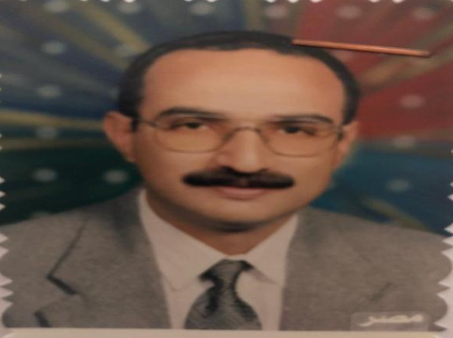
- Personal data:
Name (Arabic) | احمد سليم محمد سليم
Name (English) | Ahmed S.Mohamed
Department | Pharmacology
College | Benha faculty of medicine
Academic degree | M.D
Office Address | Department of pharmacology
Mobile 1 | 01224900786
Home phone
Work phone
Fax
Email (university)
Email (alternative) | dr_ahmedselim71@yahoo.com
Web site (if any) | drahmedselemm@gmail.com
Recent Photo (passport format)
- Education:
2.A. Degree obtained;
Institution | Degree obtained | Year
Zagazig university | M.B.BCH | 1980
Benha university | Master | 1988
Benha university | M.D | 1993

2.B. Specialty;
General specialty. | pharmacology
Specific specialty. | pharmacology

2.C. Language skills (Excellent, Very Good, Good or Basic);
Language | Reading | Speaking | Writing
Arabic. | Excellent | Excellent | Excellent
English. | Excellent | Excellent | Excellent
French.
Other (specify).

- Positions:
Tittle | Year | University/Institution
Full professor | 2016 so far | Benha university

- Cooperation with local and international entities having website:
( جامعة – مؤسسة - وزارة – مركز بحثي – عضو هيئة تدريس – باحث - شركة – مصنع – الخ)
Name of local and international entity | Website
- School of pharmacy at university of Maryland, U.S.A (1990-1992)
- Arab university in Benghazi (2000)
- Triploi university in libya (2010)
- Membership of professional bodies (List):

- Membership of institute (List):

- Distinction and Awards (List):

- Academic:
Courses at under graduate level;
1. Course name: | Clinical rounds;
2. Course name: | Lectures;
Courses at post graduate level;
1. Course name: | Clinical rounds;
2. Course name: | Lectures;
- Areas of research:
Cardiovascular system.
- PhD/M.Sc Supervision:
Title | PhD/M.Sc | Year completed / in progress

- Grants for Projects:
Funding organization | Project title | Role | Year
- Committees:

- List of Publications:
More than 35 publications.
14. Attended Workshops, Symposiums, and Conferences: "List name and year";

Name of Workshops, Symposiums, and Conferences | Year
13.1. attendance of workshops and symposiums in different departments of pharmacology in several colleges

- Books published:

16. Positions:
 | Date | Organization | Country | Position
1 | 1983-1988 |  |  | Demonstrator of pharmacology
2 | 1988-1993 |  |  | Ass.lecturer of pharmacology
3 | 1993-1999 |  |  | Lecturer of pharmacology
4 | 1999-2005 |  |  | Ass.professor of pharmacology
5 | 2005-2016 |  |  | Professor of pharmacology
6 | 2016 so far |  |  | Full professor of pharmacology

17. Activities in faculty/university/community service:
Name of Activity service | Year
- Teaching (Rounds and lectures).
- Clinical meeting.
- Making conferences.
- Medical Convoys.
- Workshops.
18. Consulting Experience (if any):

19. Additional information you would like to put on the website:

